**Tom Charman**

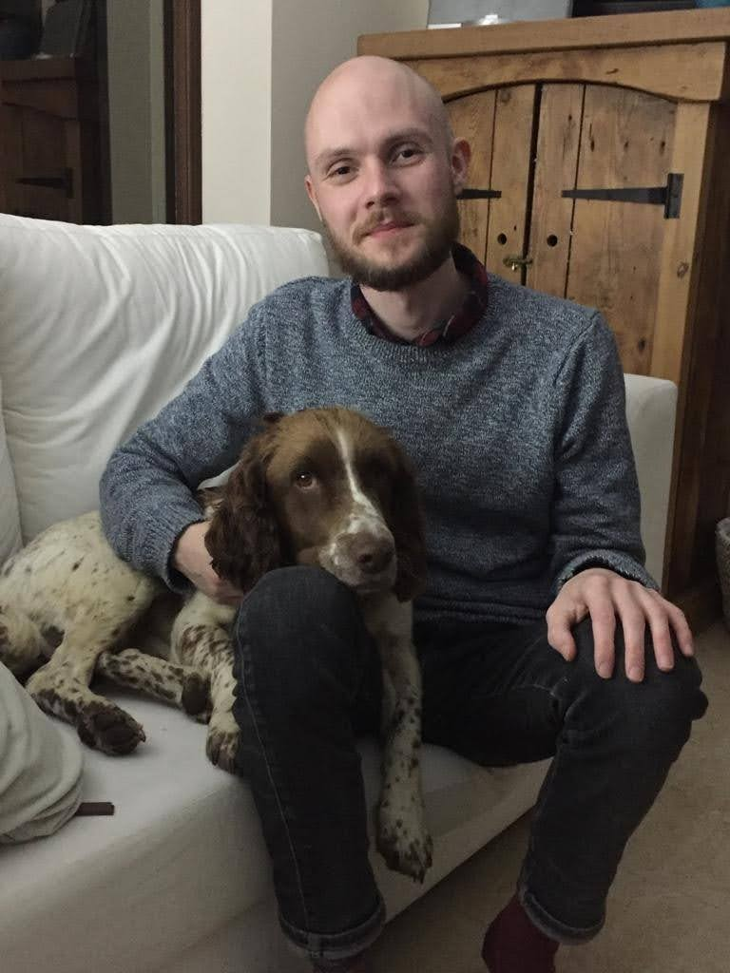

[Tom Charman](https://www.superfastessex.org/benefits-of-broadband/broadband-case-studies/tom-charman/) is a PhD student from Needham Green, who previously struggled to work from home with a 1Mbps internet connection. Now, thanks to full fibre, he can do everything he needs to with ease, from participating in meetings, to keeping in touch with friends virtually during lockdown.

See below each picture for wording you can use alongside

these images when sharing. [**Click here**](http://www.superfastessex.org/toolkit)for instructions on how to share our posts on your social media.

PhD student Tom was struggling with a 1Mbps connection before @SuperfastEssex rolled out #fullfibre in his area! Read his story here: <http://ow.ly/XNZa50CApyG> #FullFibreEssex #GigabitEssex

@SuperfastEssex's #fullfibre rollout is benefiting residents like Tom! Find out what full fibre can do for you at [www.superfastessex.org/fullfibre](https://www.superfastessex.org/fullfibre) #FullFibreEssex #GigabitEssex